**GLOBAL AIR TRANSPORTATION NETWORK**

1. **INTRODUCTION:**

**1.1 OVERVIEW:**

We analysis the global structure of the world wide air transportation network. A critical infrastructure with an enormous impact on local , national and international economies. We find that the worldwide air transportation is a scale free small-world network.

Like other critical infrastructure the air transportation network has impact international economies. It is thus natural that airports and national airline companies are often time associated with an image a country or a region want to project.

The worldwide air transportation network is responsible for the mobility of millions of people every day almost 700 million passengers fly each year. It helps the people in the aviation and transportation field.

**1.2 PURPOSE :**

The main purpose of this project is to give a clear vision to people to know about the global air transportation. This research aims to give the full information like airport, airplane, airlines and routes.

**2.1Empathy Map**

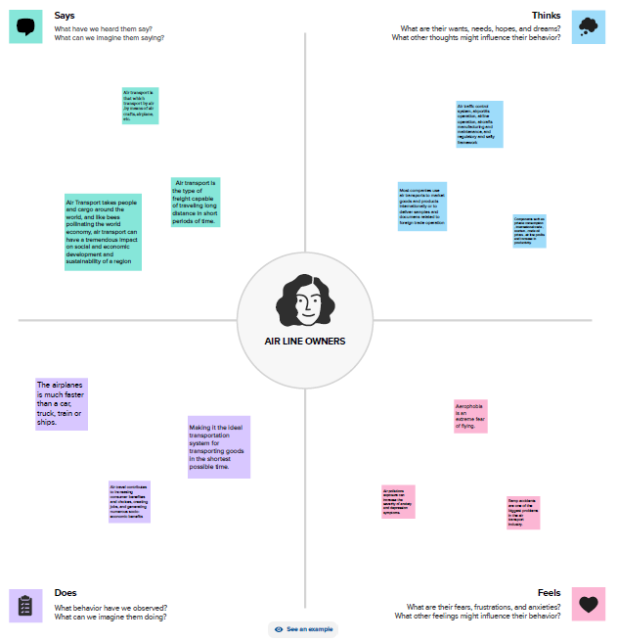

**2.2 Brainstorming Map**

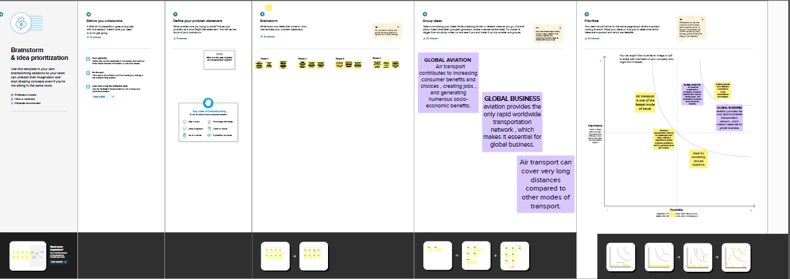

**RESULT**

**Dashboard 1**

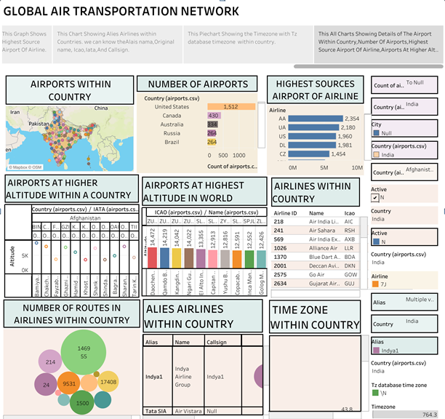

**STORY:**

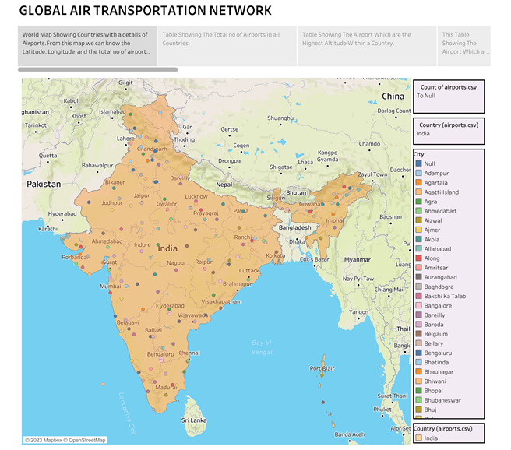

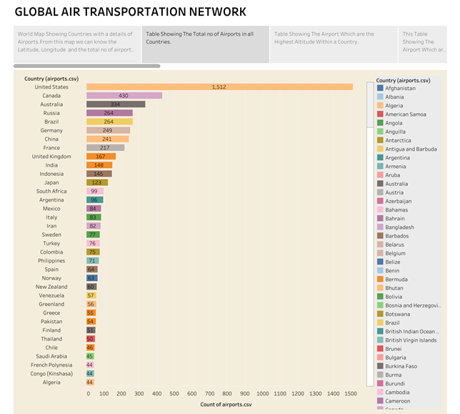

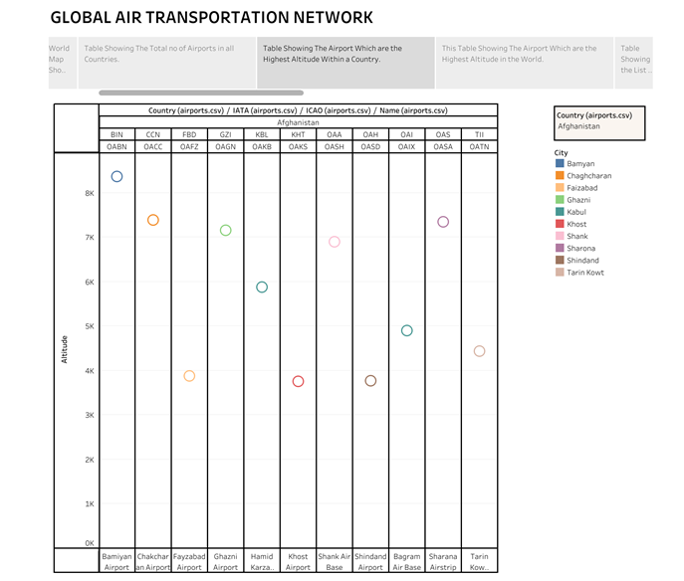

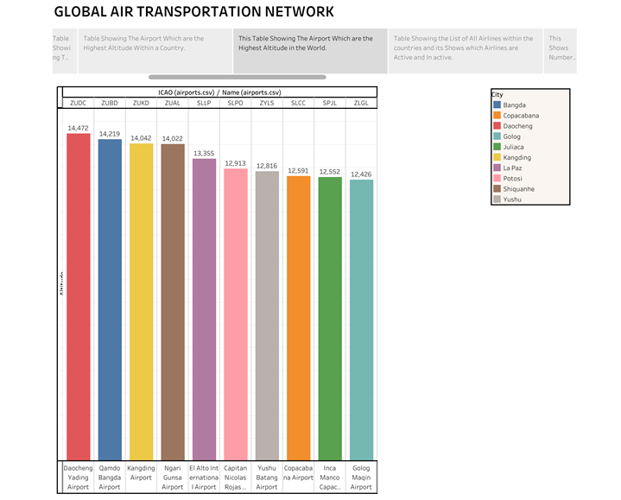

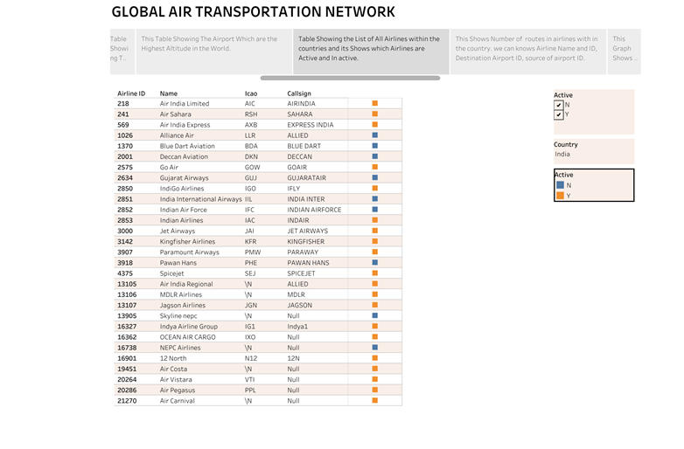

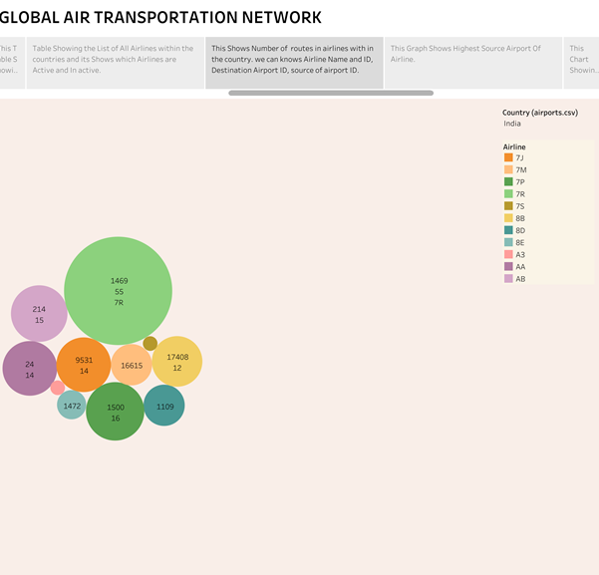

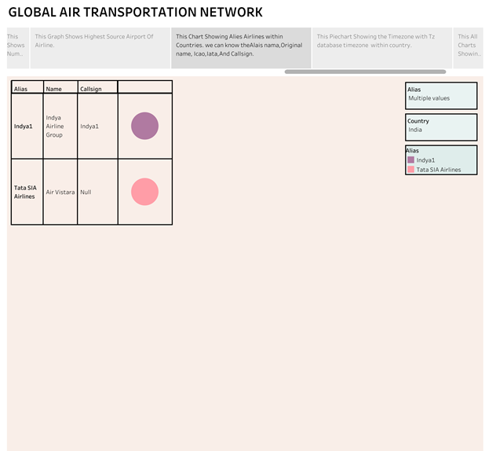

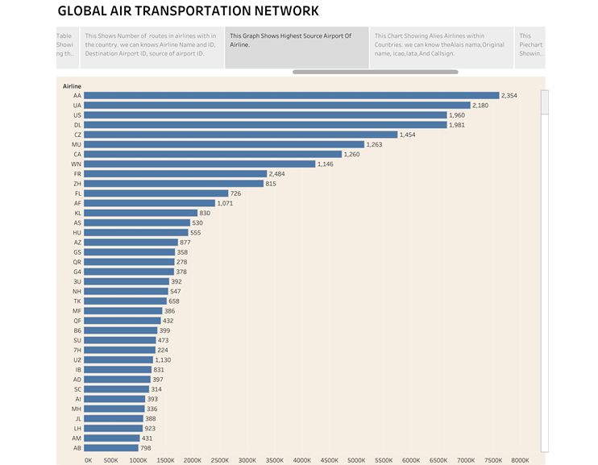

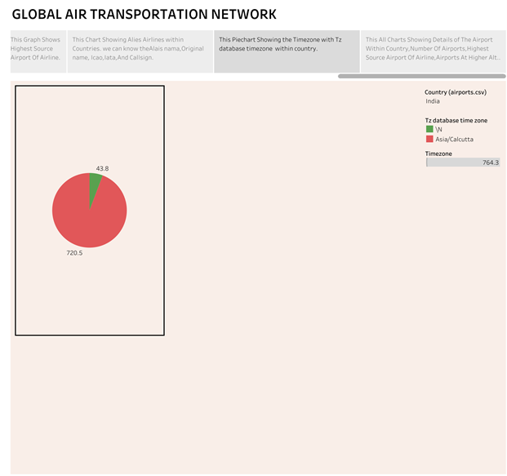



**ADVANTAGE:**

**\*** This project will help the passengers who wants to know about global air transportation.

* Air Transportation is an important enabler in achieving economic growth and development.

**\*** This project helps to know about the routes and about Airports and Airlines

**DISADVANTAGE:**

**\*** From this project, people know that the other transportation is cheaper than air transportation.

* Illiterates feel odd about the global air transportation.

**APPLICATION:**

**\*** When people enter into the air transportation field, by this project they will able to know about airlines, airports, airplanes and routes.

* Passengers can go to any places worldwide by referring this project.

**CONCLUSION:**

Problem Definitions & Design Thinking is done by creating Empathy Map and Brainstorming Map. Data Visualization is done by creating graphical representations. The goal of Data visualization is to make complex Data sets more accessible, Intuitive and easier to interpret. Dashboard for this project is created which ensure the information is easily understandable and finally story is done which is the way of presenting data and analysis in a narrative format. The main goal of storyboard is making the information more engaging and easier to understand. By this project we can able to understand about the Global Air Transportation Network.

**FUTURE SCOPE:**

The future of the aviation in India is likely to see continued growth, by the factors such as increased tourism and government polices supporting the aviation industry.